REACT ASSIGNMENTS
Assignment 9:
Aim
To create a React application named cricketapp that demonstrates the use of ES6 features such as map(), arrow functions, destructuring, and the spread operator by displaying a list of cricket players, filtering players based on their scores, separating odd and even team players, and merging multiple player arrays using React components.
1. Create a new React application named cricketapp.
npx create-react-app cricketapp
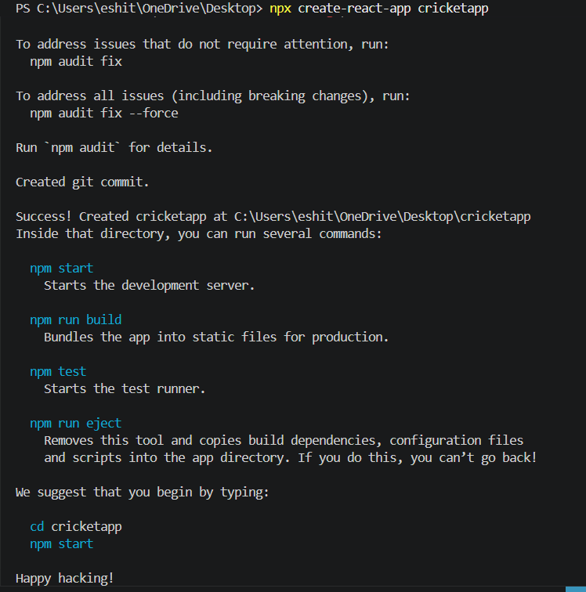

2. Navigate to the project folder.
cd cricketapp
3. App.js
import './App.css';
import ListofPlayers from './Components/ListofPlayers';
import IndianPlayers from './Components/IndianPlayers';

function App() {

const flag = true;

if (flag) {
return (
<div className="App">
<ListofPlayers />
</div>
);
}
else {
return (
<div className="App">
<IndianPlayers />
</div>
);
}
}

export default App;
4. Components/ ListofComponents.js
import React from "react";

function ListofPlayers() {

const players = [
{ name: "Virat Kohli", score: 95 },
{ name: "Rohit Sharma", score: 82 },
{ name: "Shubman Gill", score: 68 },
{ name: "KL Rahul", score: 75 },
{ name: "Hardik Pandya", score: 63 },
{ name: "Ravindra Jadeja", score: 72 },
{ name: "R Ashwin", score: 54 },
{ name: "Mohammed Shami", score: 49 },
{ name: "Jasprit Bumrah", score: 85 },
{ name: "Mohammed Siraj", score: 66 },
{ name: "Kuldeep Yadav", score: 70 }
];

const below70 = players.filter(player => player.score < 70);

return (
<div>

<h1>List of Players</h1>

{players.map((player, index) => (
<div key={index}>
<h3>
{player.name} - {player.score}
</h3>
</div>
))}

<hr />

<h2>Players with Score Below 70</h2>

{below70.map((player, index) => (
<div key={index}>
<h3>
{player.name} - {player.score}
</h3>
</div>
))}

</div>
);
}

export default ListofPlayers;

5. Components/ IndianPlayers.js
import React from "react";

function IndianPlayers() {

const players = [
"Virat",
"Rohit",
"Gill",
"Rahul",
"Hardik",
"Jadeja"
];

const [
odd1,
even1,
odd2,
even2,
odd3,
even3
] = players;

const T20Players = [
"Surya",
"Tilak",
"Rinku"
];

const RanjiPlayers = [
"Pujara",
"Rahane",
"Sarfaraz"
];

const mergedPlayers = [
...T20Players,
...RanjiPlayers
];

return (

<div>

<h1>Odd Team Players</h1>

<h3>{odd1}</h3>
<h3>{odd2}</h3>
<h3>{odd3}</h3>

<hr />

<h1>Even Team Players</h1>

<h3>{even1}</h3>
<h3>{even2}</h3>
<h3>{even3}</h3>

<hr />

<h1>Merged Players</h1>

{mergedPlayers.map((player, index) => (
<h3 key={index}>{player}</h3>
))}

</div>

);
}

export default IndianPlayers;
6. Output

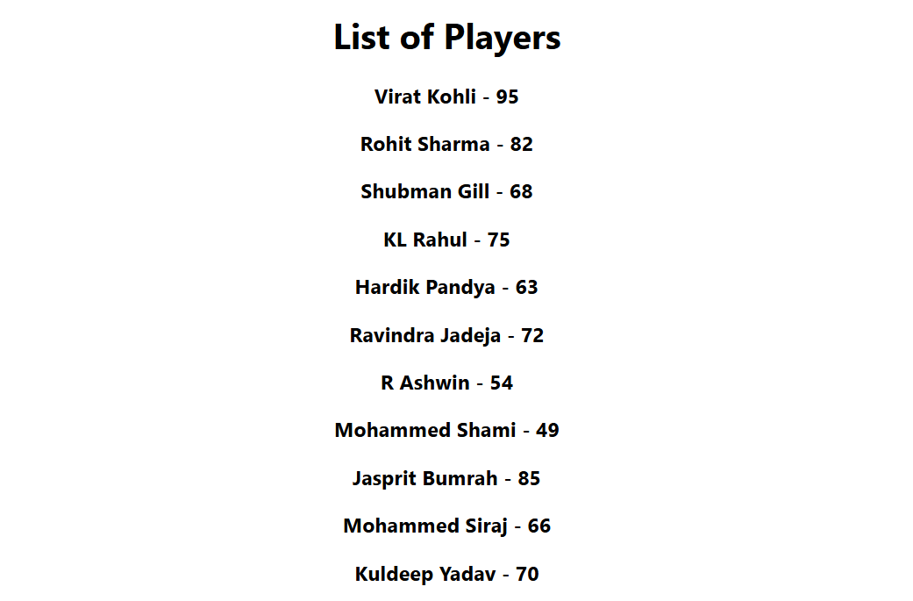
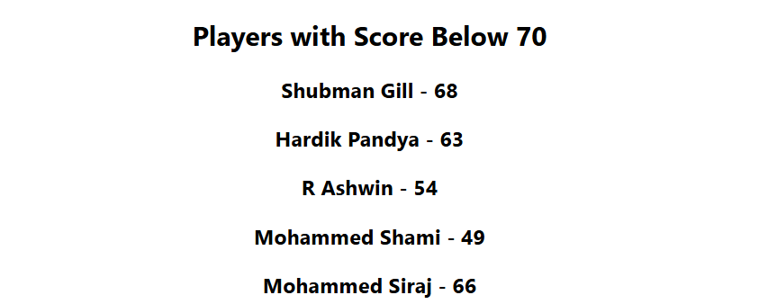

7. Result
The React application was developed successfully. The list of cricket players was displayed using the map() method, players scoring below 70 were filtered using arrow functions, odd and even team players were displayed using destructuring, and the T20 and Ranji Trophy player arrays were merged using the spread operator.
8. Conclusion
The experiment was completed successfully. A React application named cricketapp was created to demonstrate the use of ES6 features, including map(), arrow functions, destructuring, and the spread operator. Components were rendered conditionally using a simple if-else statement based on a flag variable.

